QUESTION 1

<!DOCTYPE html>

<html lang="english">

<hd>

<title>css selector</title>

<style>

p{color:rgb(214, 223, 89)}

.highlight{

background-color: rgb(25, 23, 189);

}

    #intro{

font-size: 1.2px;

font font-weight: bold ;

}

*{ font-family: 'Franklin Gothic Medium', 'Arial Narrow', Arial,

sans-serif;

font-size: medium;

}

</style>

</haed>

<body>

<h1>welcome</h1>

<div id="intro">

<p class="highlight">this paragraph is highlighted.</p>

</div>

<p>A regular paragraph.</p>

<h2>section 1</h2>

<p>paragraph after the h2.</p>

<p>another paragraph</p>

<h2>Section 2</h2>

<p>A paragraph.</p>

<a href="https://www.google.com">Google Link</a>

</body>

</html>

QUESTION 1 OUTPUT

**welcome**

this paragraph is highlighted.

A regular paragraph.

**section 1**

paragraph after the h2.

another paragraph

**Section 2**

A paragraph.

[Google Link](https://www.google.com)

QUESTION 2

[8:30 PM, 2/24/2025] Nishtha: <!DOCTYPE html>

<html lang="en">

<head>

<meta charset="UTF-8">

<meta name="box models" content="width=devise=width">

<title> box model</title>

<style>

.box{ box-align: center;

width: 300px;

margin: 15px;

border: 5px solid black;

padding: 15px;

background-color: rgba(29, 43, 241, 0.863);

text-align: center;

}

.box h1{

color: rgb(12, 20, 28);

text-transform: uppercase;

}

.box p{

color: rgb(161, 247, 22);

text-transform: lowercase;

}

</style>

</head>

<body>

[8:30 PM, 2/24/2025] Nishtha: <div class="box">

<h1>box model</h1>

<p>this paragraph is box model in CSS.the box has

margin,paddind...</p>

</div>

</body>

</html>

QUESTION 2 OUTPUT

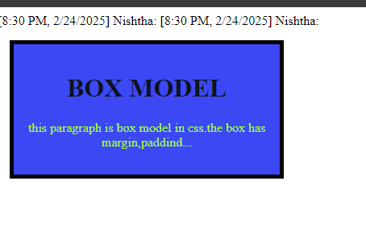

QUESTION 3

<!DOCTYPE html>

<html lang="en">

<head>

    <meta charset="UTF-8">

    <meta name="viewport" content="width=device-width, initial-scale=1.0">

    <title>Registration Form</title>

    <style>

        body {

            font-family: Arial, sans-serif;

            background-color:powderblue;

            font-size: 18px;

            align-items: centre;

            text-align: centre;

            padding: 20px;

        }

    </style>

</head>

<body>

    <h1>Registration Form</h1>

    <form>

        <label for="name">Name:</label>

        <input type="text" id="name" name="name" required><br><br>

        <label for="email">Email:</label>

        <input type="email" id="email" name="email" required><br><br>

        <label>Gender:</label>

        <input type="radio" id="male" name="gender" value="male" required>

        <label for="male">Male</label>

        <input type="radio" id="female" name="gender" value="female" required>

        <label for="female">Female</label><br><br>

        <label>Interests:</label>

        <input type="checkbox" id="reading" name="interests" value="reading">

        <label for="reading">Reading</label>

        <input type="checkbox" id="music" name="interests" value="music">

        <label for="music">Music</label>

        <input type="checkbox" id="sports" name="interests" value="sports">

        <label for="sports">Sports</label><br><br>

        <input type="submit" value="Submit">

        <input type="reset" value="Reset">

    </form>

</body>

</html>

QUESTION 3 OUTPUT

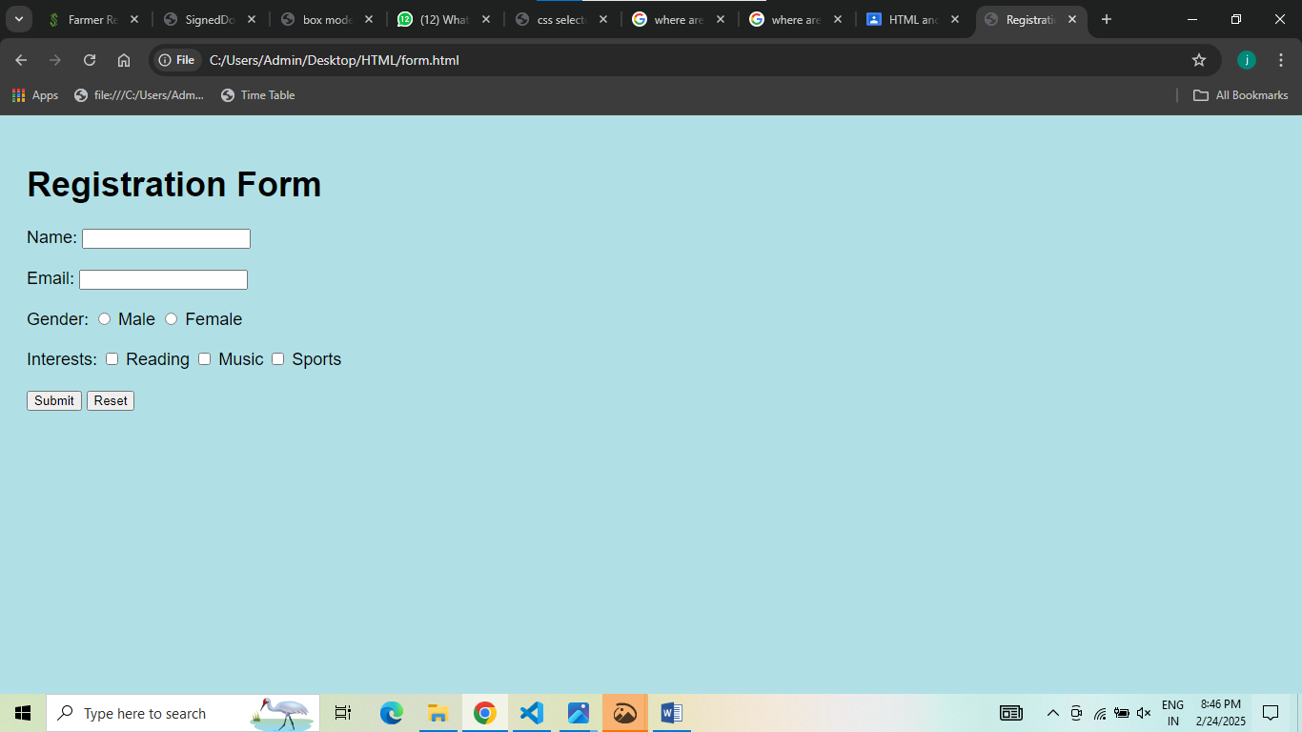

QUESTION 4

<!DOCTYPE html>

<html lang="en">

<head>

    <meta charset="UTF-8">

    <meta name="viewport" content="width=device-width, initial-scale=1.0">

    <title>Responsive Design</title>

    <style>

        body {

            font-family: Arial, sans-serif;

            background-color: white;

            font-size: 18px;

            text-align: left;

            padding: 20px;

        }

        @media (min-width: 1000px) {

            body {

                background-color: lightblue;

            }

        }

        @media (max-width: 1500px) {

            body {

                background-color:palegreen;

            }

        }

    </style>

</head>

<body>

    <h1>Responsive Design Example</h1>

    <p>Resize the browser window to see the background color and text alignment change.</p>

</body>

</html>

QUESTION 4 OUTPUT

